WORKBOOK ASSIGNMENT-4
Working with Multiple Tables and Joins

Q1) Create a MySQL database named CollegeDB and create the following tables:

Student Table
Column Name Data Type
Constraint
StudentID
INT
PRIMARY KEY
StudentName
VARCHAR(50)38
B.SC. DATA SCIENCE
Column Name Data Type
Constraint
City
VARCHAR(30)
Course Table
Column Name Data Type
Constraint
CourseID
INT
PRIMARY KEY
CourseName
VARCHAR(50)
Fees
DECIMAL(10,2)
Enrollment Table
Column Name Data Type Constraint
EnrollmentID
INT
PRIMARY KEY
StudentID
INT
FOREIGN KEY
CourseID
INT
FOREIGN KEY
EnrollmentDate DATE

-- Create Database
CREATE DATABASE SeniorCollegeDB;
USE SeniorCollegeDB;

-- Create Student Table
CREATE TABLE Student (
StudentID INT PRIMARY KEY,
StudentName VARCHAR(50),
City VARCHAR(30)
);

-- Create Course Table
CREATE TABLE Course (
CourseID INT PRIMARY KEY,
CourseName VARCHAR(50),
Fees DECIMAL(10,2)
);

-- Create Enrollment Table
CREATE TABLE Enrollment (
EnrollmentID INT PRIMARY KEY,
StudentID INT,
CourseID INT,
EnrollmentDate DATE,
FOREIGN KEY (StudentID) REFERENCES Student(StudentID),
FOREIGN KEY (CourseID) REFERENCES Course(CourseID)
);
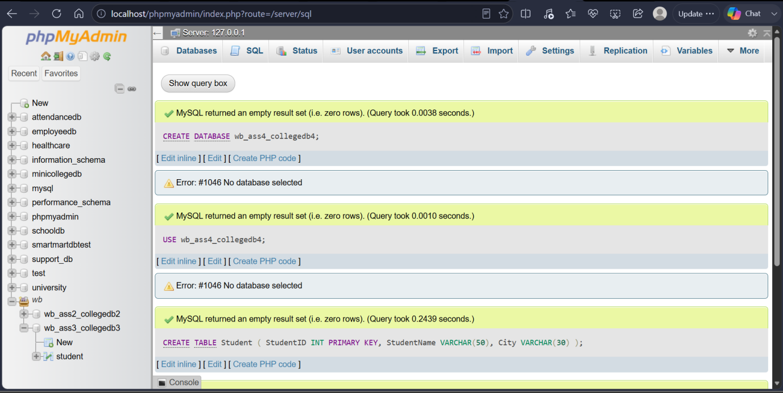

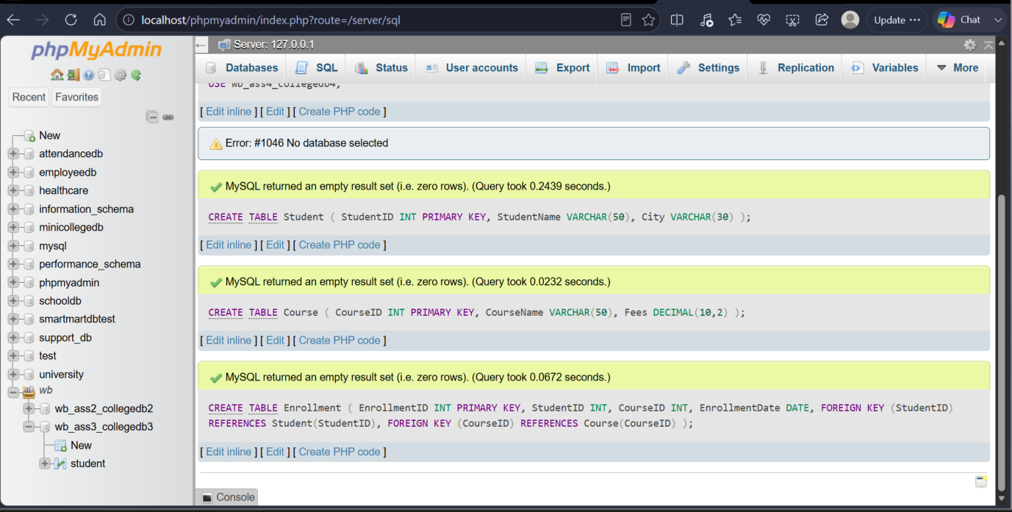

Q2) Insert at least 6 records into the Student table, 4 records into the Course table, and 5 records into the Enrollment table. Make sure:
Requirement
At least one student should not have enrollment
At least one course should not have any enrolled student

-- Insert into Student table
INSERT INTO Student VALUES
(1, 'Alice', 'NY'),
(2, 'Bob', 'LA'),
(3, 'Charlie', 'SF'),
(4, 'Dave', 'CHI'),
(5, 'Eve', 'MIA'),
(6, 'Frank', 'SEA');

-- Insert into Course table
INSERT INTO Course VALUES
(101, 'Math', 500.00),
(102, 'Science', 600.00),
(103, 'Art', 300.00),
(104, 'History', 400.00);

-- Insert into Enrollment table
INSERT INTO Enrollment VALUES
(1001, 1, 101, '2023-01-01'),
(1002, 2, 101, '2023-01-02'),
(1003, 3, 102, '2023-01-03'),
(1004, 4, 103, '2023-01-04'),
(1005, 5, 103, '2023-01-05');
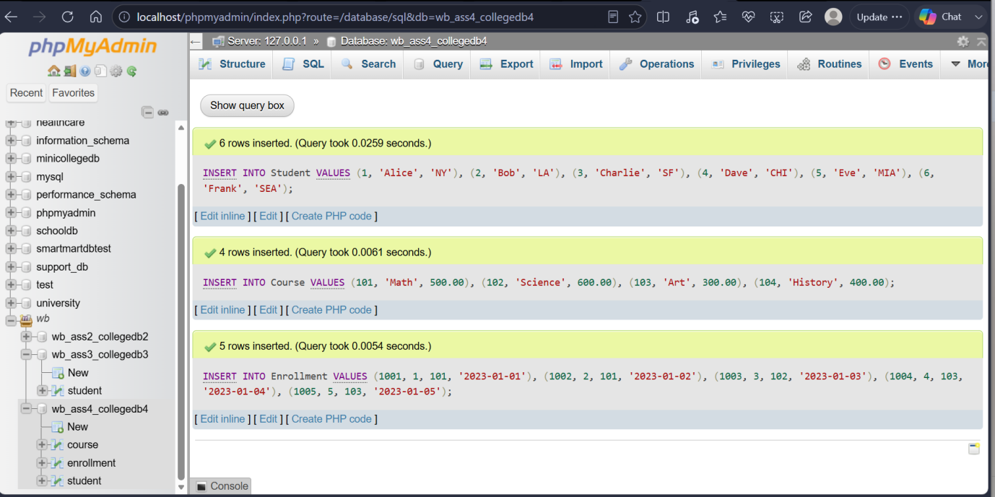

Q3) Write a MySQL query using INNER JOIN to display students who have enrolled in courses. The output should include:
Column
StudentID
StudentName
CourseID
EnrollmentDate

SELECT Student. StudentID,
Student. StudentName,
Enrollment. CourseID,
Enrollment. EnrollmentDate
FROM Student
INNER JOIN Enrollment ON
Student. StudentID =
Enrollment. StudentID;

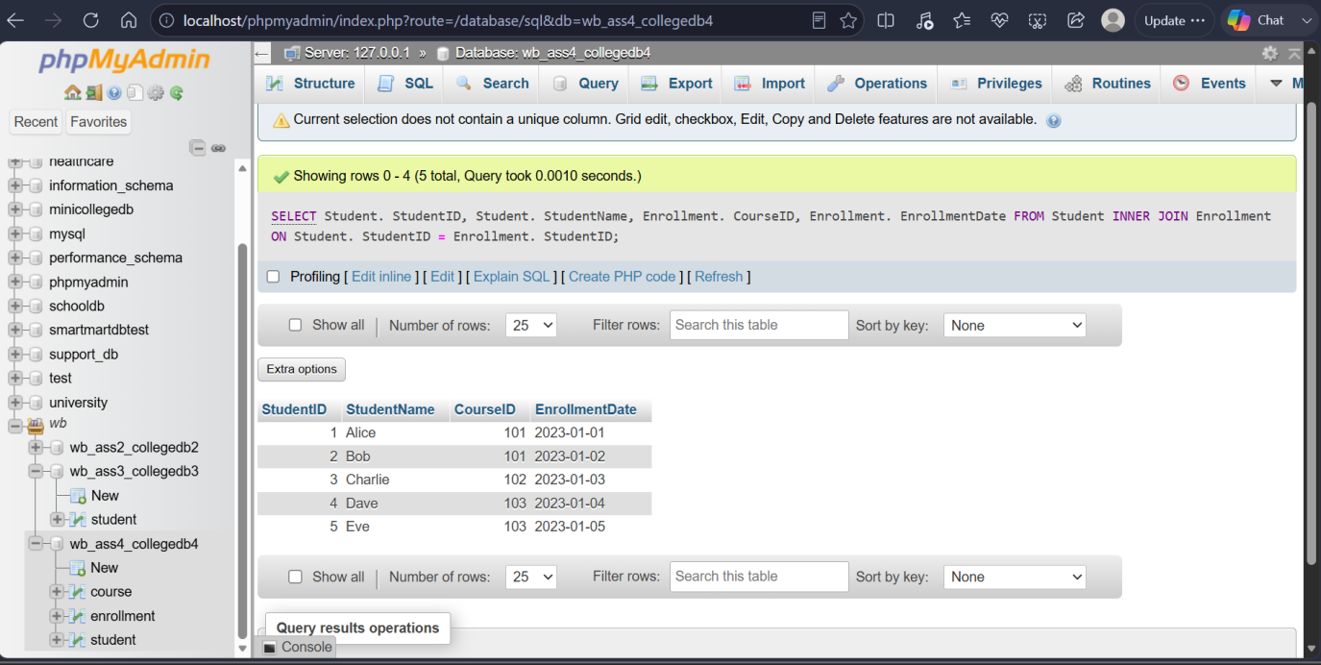

Q4) Write a MySQL query to display student name, city, course name, fees, and enrollment date using multiple tables. Use:
Tables Required
Student
Course
Enrollment

SELECT Student. StudentName,
student. city,
Course. CourseName,
Course. Fees,
Enrollment. EnrollmentDate
FROM Student
JOIN Enrollment ON
Student. StudentID =
Enrollment. StudentID
JOIN Course ON Enrollment. CourseID
= Course. CourseID;

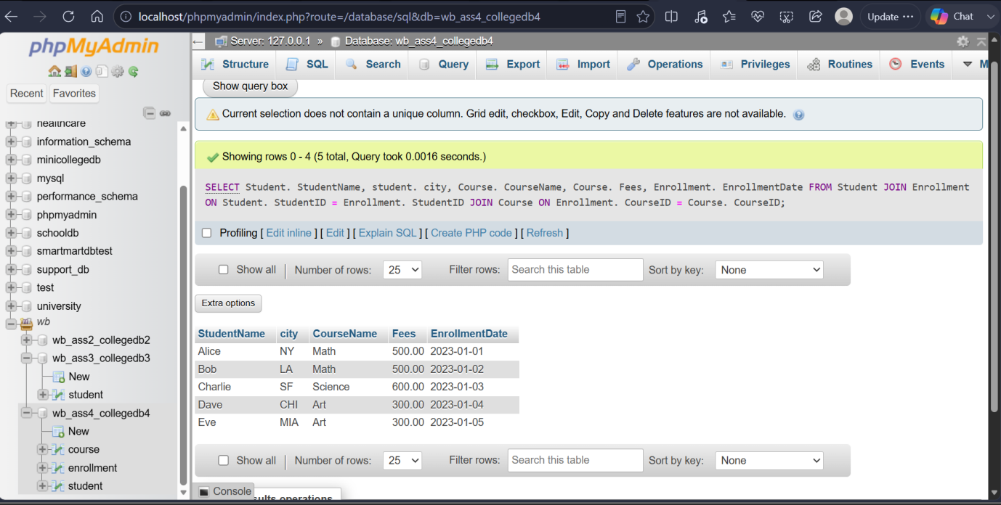
Q5) Write a MySQL query using LEFT JOIN to display all students, including those who have not enrolled in any course. The output should include:
Column
StudentID
StudentName
City
CourseID
EnrollmentDate

SELECT Student. StudentID,
Student. StudentName,
Student. City,
Enrollment. CourseID,
Enrollment. EnrollmentDate
FROM
Student
LEFT JOIN Enrollment
ON Student.StudentID = Enrollment.StudentID;

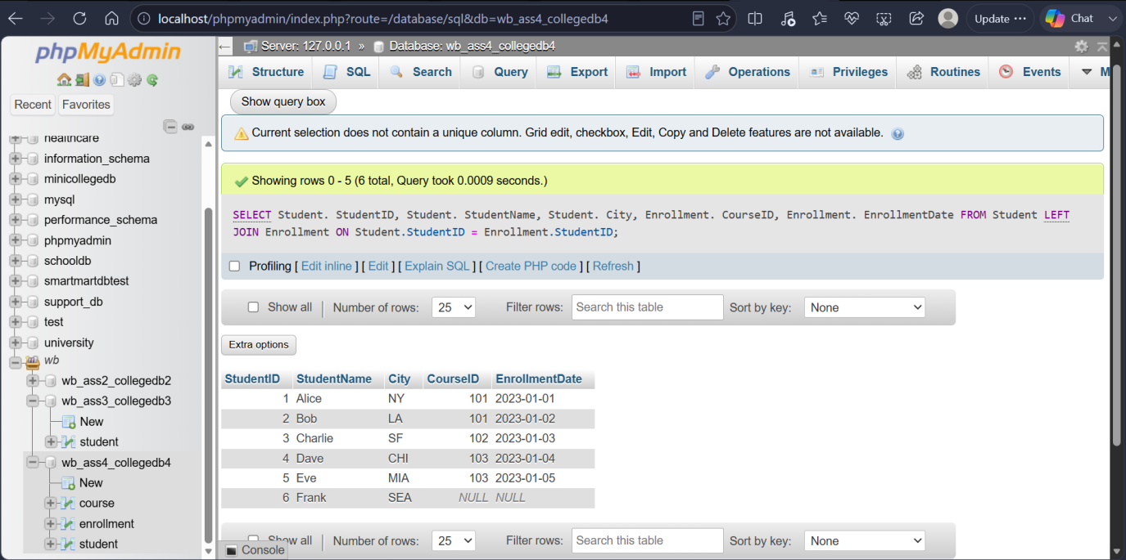

Q6) Write a MySQL query using RIGHT JOIN to display all courses, including courses that have no enrolled students. The output should include:
Column
StudentName
CourseID
CourseName
Fees

SELECT Student.StudentName,
Course. CourseID,
Course. CourseName,
Course. Fees
FROM Student
JOIN Enrollment ON
Student.StudentID = Enrollment.StudentID
RIGHT JOIN Course ON
Enrollment. CourseID = Course. CourseID;

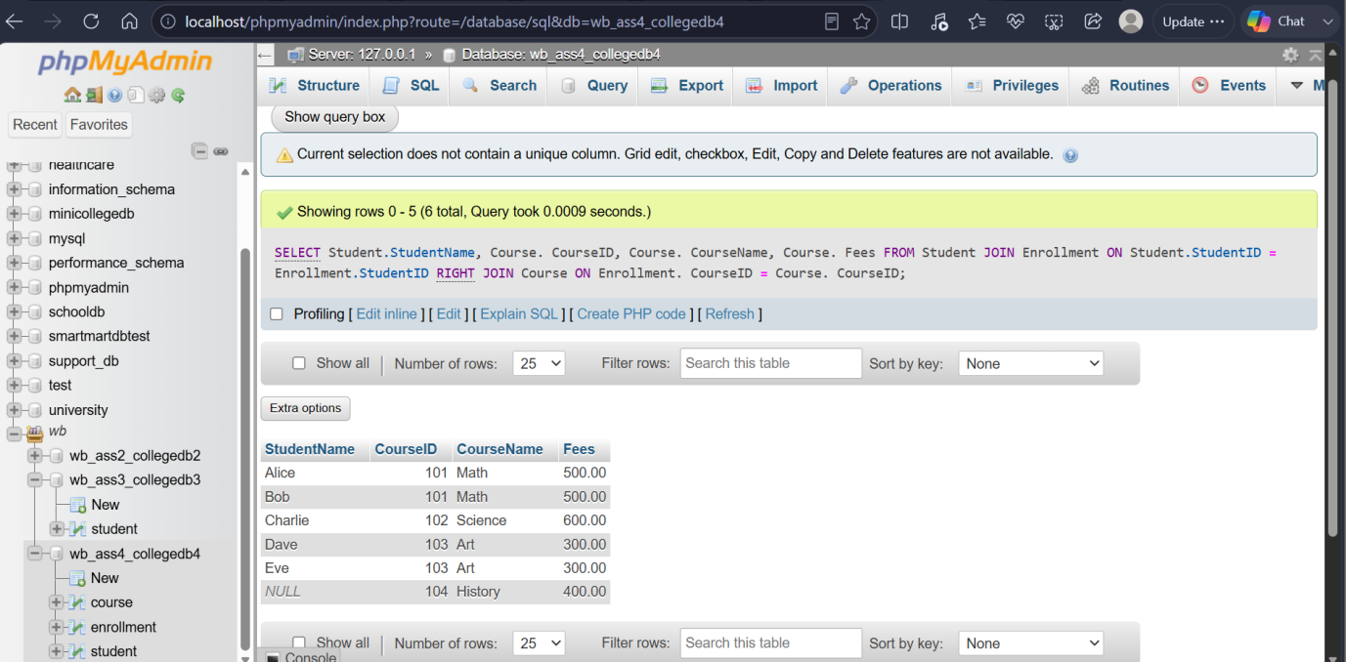

THANK YOU

